Logistic Regression:

1. Model: log(P(win)/P(loss)) = beta0 + beta1*Review + beta2*PG +beta3*R

PG-13 is releveled

|  |  |  |
| --- | --- | --- |
| Variable | Estimated regression coefficient | standard error |
| Review | 0.0476626 | 0.03895 |
| PG | -0.0001544 | 1.160129 |
| R | 0.2390888 | 0.5529918 |

1. For each additional unit of Rotten Tomatoes Tomatometer we estimate the mean number of wins increases by 4.88% holding all else constant (95% CI: -1.85%, 14.6%)
2. there is no statistical significant difference between R and PG-13

p-value = 0.6655

in log-odds: R rating movie are more likely to win the award than PG-13

odds-ratio:

R rating movie holding all else constant mean have a 27% (95%CI: -56.1%,297%)

1. Test Ho : MPAA Rating has no effect on winning the Academy Award at α = 0.05.

ANOVA chisq test:

The test statistic is 0.20786 and the p-value is 0.9013.

We fail to reject the null hypothesis. MPAA Rating has no effect on winning the Academy Award at α = 0.05.

The MPAA rating does not affect whether the movie will win the Academy Award.

The MPAA rating of a movie does not reflect how good the movie is. We should not judge a movie depending on its MPAA rating.

1. The probability of winning the Academy Award for Best Picture for Black Panther which is rated PG-13 and has a Tomatometer score of 97 is 16.7% (95% CI: 6.76%, 35.7%).
2. ROC curve

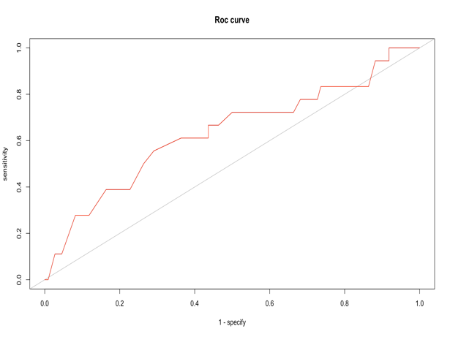

1. AUC = 0.6338384
2. AUC measure how accurate the model predicts the data. The model is better when AUC is closer to 1. When AUC is 0.5, the model is just as good as flipping a coin. The AUC represents how accurate the model predicts.